# **Texture in Graphic Design**

## **Reach Out and Touch the Art**

**Texture** is the way the surface of a composition feels or is perceived to feel. This means you can create an illusion of texture in the way you place your images or through the use of line and shading.

## **What Texture Can Do for You**

* Texture can be a powerful tool to draw a viewer's attention and engage them in many subconscious ways.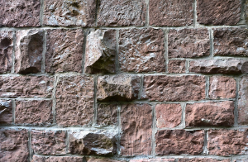
* Certain types of texture can evoke subtle emotional responses, while others excite the visual senses.
* Texture can be used to create balance and enhance a sense of seriousness or gentleness.

## **Actual/Physical Texture**

Texture comes in two primary forms, **actual** and **implied**. However, both go by a number of different names, depending on who is talking about it. That's why we included several in the heading.

**Actual texture**, or physical texture, refers to the real tactile properties of a design. This can include how the surface feels, such as rough or smooth, the way words might be raised from the surface or pressed into it, and even the physical weight of the piece.

***You can identify actual texture in the weight of the paper, the raised flower pattern, and the letter M affixed on top of the paper.***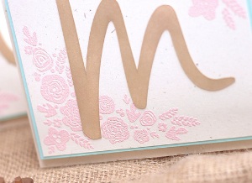

## **Implied/Visual/Virtual/ Texture**

**Implied texture**, also called visual or virtual texture, is the illusion of texture created by color, lines, shadows, and other elements in your design composition. Think about a photograph of an old, gnarled tree. You can tell the bark is very rough to the touch, but the photograph has a completely flat surface. The way other elements of design are incorporated into the image helps convey the information that the subject of the photo has a particular texture, even when the piece of art doesn't have that quality at all.

However, not all implied, or visual, texture is the same, and the two major types - image texture and pattern texture - can evoke different feelings.

### **Image Texture**

**Image texture** is created with organic shapes and color. There is no uniform repetition of the textural aspects and it can appear very natural, regardless of the degree of complexity.

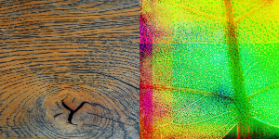

**The wood grain and the veins of a leaf are both image texture.**

### **Pattern Texture**

On the other hand, **pattern texture** stimulates the visual senses and reasoning through geometric shapes and repeated, orderly elements. The uniformity of a pattern texture, especially in a background, can create balance in a composition and a sense of control.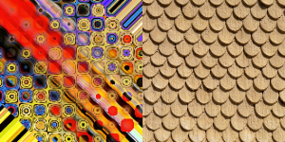

**You can identify both of these examples as patterned texture because of the geometric shapes and repetition.**